Университет ИТМО, факультет программной инженерии и компьютерной техники
Двухнедельная отчётная работа по «Информатике»: аннотация к статье

Дата прошедшей лекции | Номер прошедшей лекции | Название статьи/главы книги/видеолекции | Дата публикации (не старше 2022 года) | Размер статьи (от 400 слов) | Дата сдачи
10.09.2025 | 1 | Decimal Versus Binary Representation of Numbers in Computers | 1.10.2022 | 4424 | 24.09.2025
24.09.2025 | 2 | Data Compression Technology Explained: Balance between Costs & Performance | 8.11.2022 | 2562 | 08.10.2025
 | 3
 | 4
 | 5
 | 6
 | 7

Выполнил(а) Цэрэндорж Ариунбат , № группы P3113 , оценка
^{Фамилия И.О. студента} ^{не заполнять}
Прямая полная ссылка на источник или сокращённая ссылка (bit.ly, tr.im и т.п.)
https://oceanbase.medium.com/data-compression-technology-explained-balance-between-costs-performance-e7330bca0d34
Теги, ключевые слова или словосочетания (минимум три слова)
Data compression technology, compression performance balance, adaptive compression
Перечень фактов, упомянутых в статье (минимум четыре пункта)
- Compression saves disk space but isn’t free. Higher compression usually means more CPU work to compress/decompress, and that extra CPU or extra I/O can slow latency-sensitive operations.
- OLTP systems (which handle lots of small, real-time transactions) don’t use much compression because it can slow performance.
- OLAP systems (used for analytics) can use stronger compression since they process large batches of data less frequently.
- OceanBase first encodes columns, then compresses them which saves more space.
- Different compressors trade speed for ratio: LZ4/Snappy are very fast but compress less, on the other hand, zlib/zstd compress more (zstd also decompresses relatively quickly).
Позитивные следствия и/или достоинства описанной в статье технологии (минимум три пункта)
- High compression ratios mean less disk space is needed, which reduces hardware and storage expenses.
- Smaller data blocks reduce network usage during replication, backups, and data loading.
- Multiple algorithms (LZ4, Snappy, zstd, etc.) let users choose between speed and compression ratio depending on the purpose of the use.
- Smaller data volumes mean fewer servers and disks are needed as the system grows.
Негативные следствия и/или недостатки описанной в статье технологии (минимум три пункта)
- Compression and decompression require extra processing power, which can slow down systems with many real-time transactions.
- When the database needs to access compressed data, it must decompress it before using it. That extra step can increase delay for users or applications that expect quick results, especially in systems that handle real-time requests (like OLTP).
- It’s not easy and straight forward to find the right balance between saving space and keeping good speed.
- For small or constantly changing data, compression might give little benefit but still use CPU which isn’t always worth it.
Ваши замечания, пожелания преподавателю или анекдот о программистах
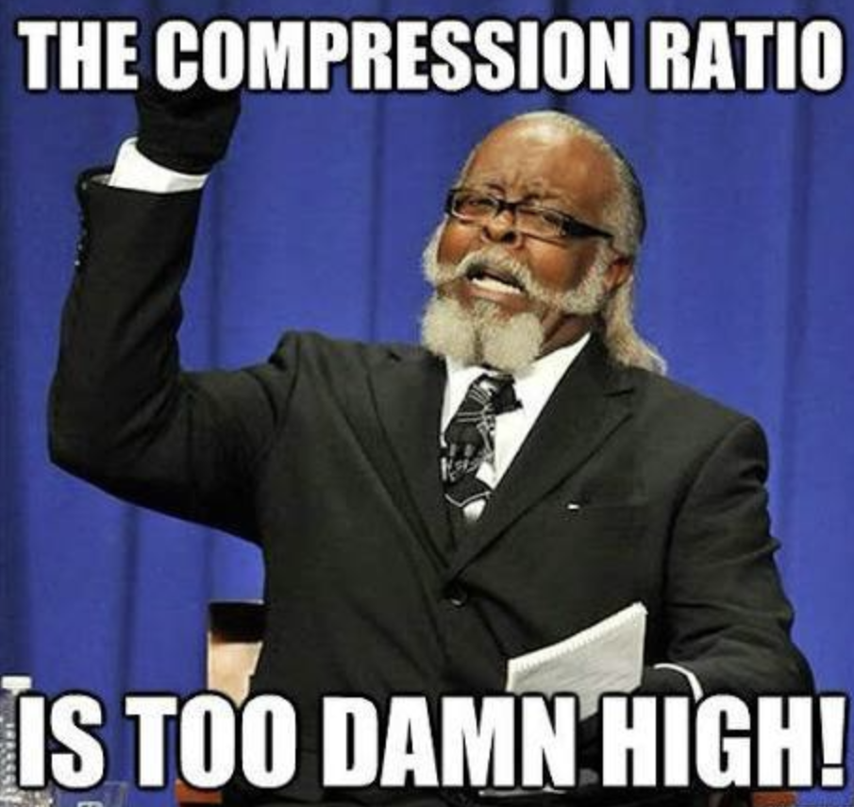

Наличие этой графы не влияет на оценку

